**Loops**

* when a block of code needs to be executed several number of times. In general, statements are executed sequentially: The first statement in a function is executed first, followed by the second, and so on.
* A loop statement allows us to execute a statement or group of statements multiple times.

**Following types of loops:**

**1).while loop**

**2).for loop**

**3).do while**

**While loop:**

**A while loop in C programming repeatedly executes a target statement as long as a given condition is true.**

**Syntax:**

Initialization;

while(condition)

{

statement(s);

increment/decrement;

}

**Example:**

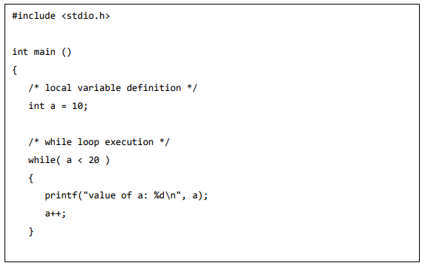

**ForLoop:**

A for loop is a repetition control structure that allows you to efficiently write a loop that needs to execute a specific number of times.

**Syntax:**

for ( init; condition; increment ) {

statement(s);

}

**Example:**

#include<stdio.h>

int main () {

/* for loop execution */

for( int a = 10; a < 20; a = a ++ ){

printf("value of a: %d\n", a);

}

Return 0;

}

**Do..whle Loop:**

**do...while loop in C programming checks its condition at the bottom of the loop.**

**Syntax:**

Initialization;

do {

statement(s);

increment/decrement;

}while( condition );

**Example:**

